**Pharmaceutical Marketing Assessment**

(Data Analysis Dashboards and KPI’s)

1. Sales and data overview

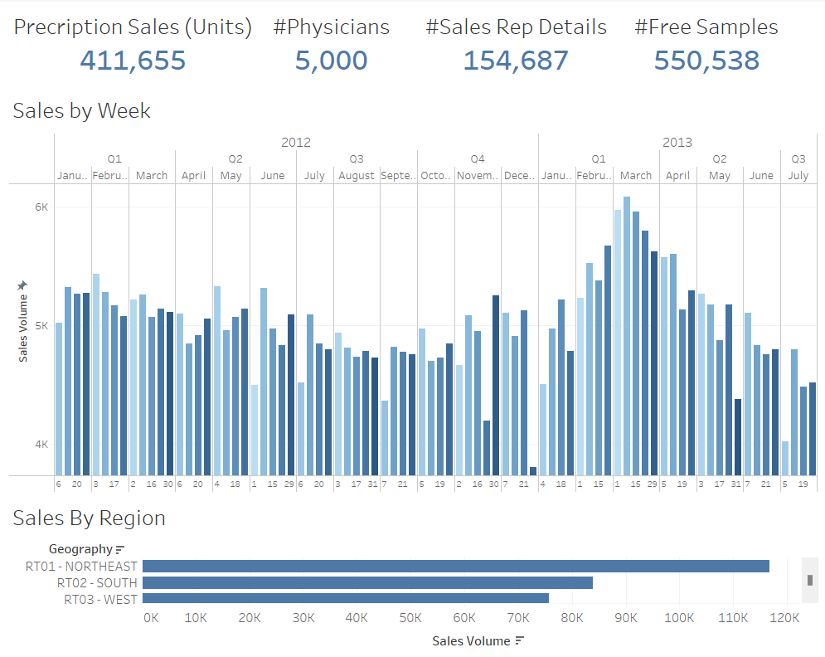

2. Correlation of marketing activities

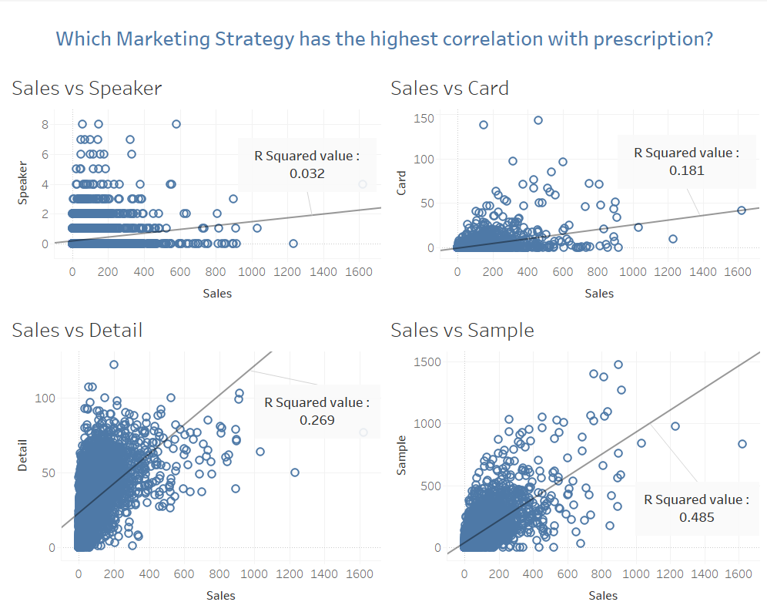

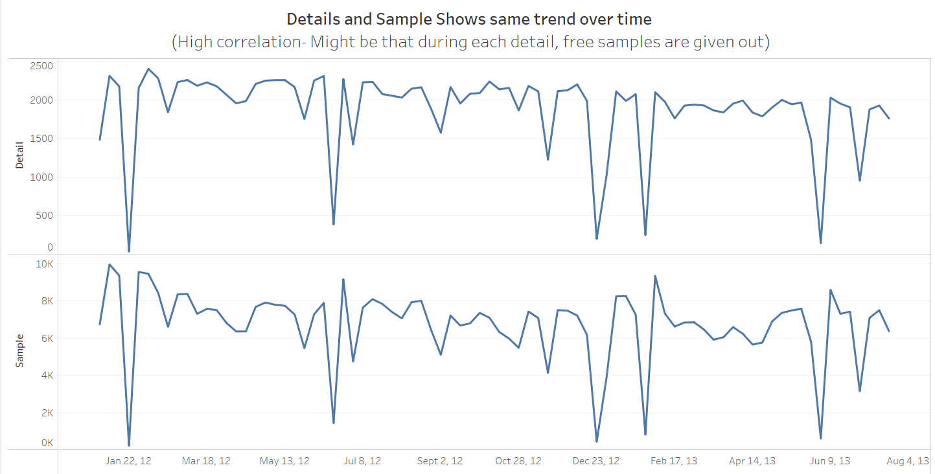

3. Analyzing Each Marketing strategy V.S. Sales (Grouped on Region & Industry ranking)

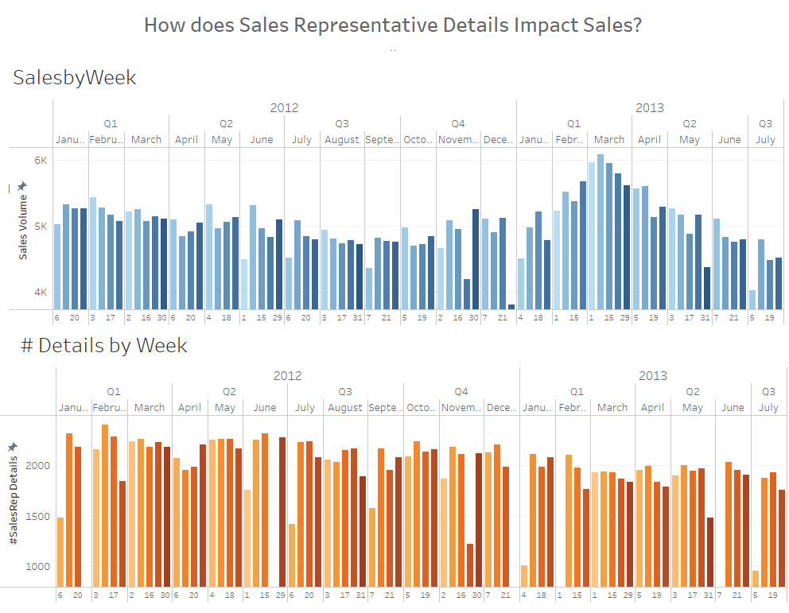

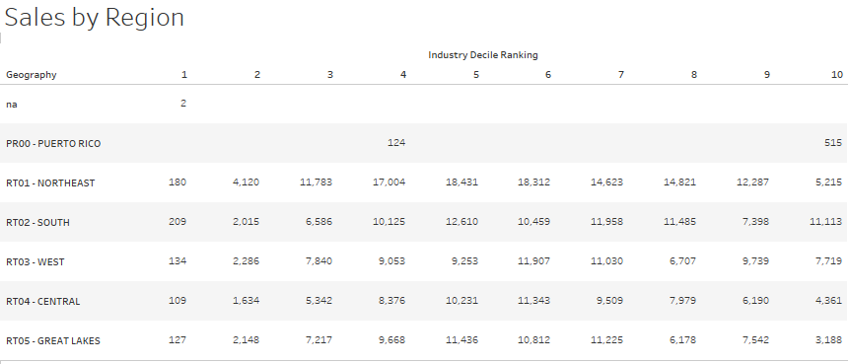

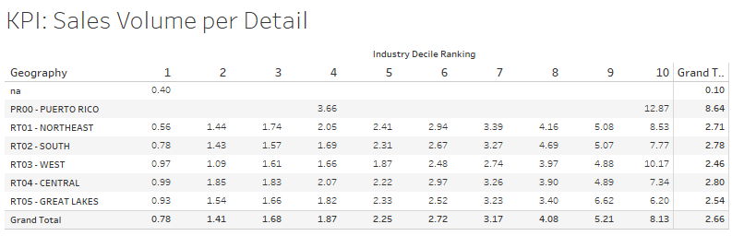

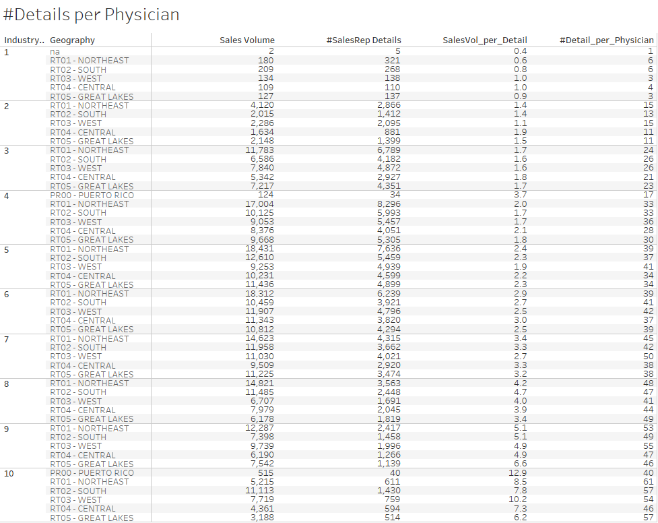

**Within the same industry decile ranking, benchmark and compare KPIs, e.g. :**

Industry decile 10: West Zone (54 details per physician, makes 10.2 units sold per detail)

Vs. Great Lakes (57 details per physician, makes 6.2 units sold per detail.



Industry decile 8: West Zone (41 details per physician, makes 4 units sold per detail)

Vs. Great Lakes (49 details per physician, makes 3.4 units sold per detail

